Short channel SOI MOSFET as a quantum confinement device

A. A. Orlikovsky, V. V. Vyurkov, and V .F. Lukichev

Institute of Physics and Technology of the Russian Academy of
Sciences, Nakhimovskiy Prospekt 34, Moscow 117218, Russia
E-mail: orlikovsky@ftian.oivta.ru

The nearest break-through in silicon VLSI technology challenges the transition to silicon-on- insulator (SOI) wafers. Just these structures fiercely battle against short channel effects which gravely impair the bulk silicon MOSFET performance. The continuing employment of bulk silicon in 65nm technological node and even below entails a heavily doped transistor channel to suppress leakage source-drain current in OFF-state. Doping inevitably degrades mobility and diminishes the maximum achievable frequency. In other words, one has to sacrifice a high frequency in favor of low leakage current. Worth noting the temporal situation differs from that in the era of micrometer and sub-micrometer transistors. The transit time delay is no more the main cause to restrict the frequency. Charging of source, drain and gate capacitances become more crucial. Hopefully, the introduction of high conducting materials (silicides and metals) for electrodes will eliminate that predominance.
In our opinion, when it happens the ultra-thin (1-5nm) fully depleted silicon will be a structure to take an ultimate advantage of SOI wafers and to provide an advancement of silicon technology to the extreme channel length when a direct tunneling current between source and drain in OFF-state becomes too high. Different theoretical estimations set a limit at 5-10nm.
Until then we have a preference for UTSOI because of following reasons which are based on computer simulation performed by the program BALSOI developed at FTIAN [1, 2]:
1) In the undoped silicon channel the carrier mobility allows to achieve a ballistic regime for 10-100nm channel length. The corresponding transit delay time for thermal velocity 10⁷cm/s is equal to 10⁻¹³-10⁻¹² s, respectively.
2) In ballistic regime the channel conductivity in ON-state is restricted solely by a conductance quantum G₀= (26kOhm)⁻¹. For ultimate one-mode channel and technological node of 10nm for source/drain contacts (corresponding capacitance is about 10⁻¹⁸F) the RC-delay time attains 10⁻¹⁴s which is much smaller compared to the foregoing transit delay time.
3) For silicon body of thickness much smaller than a gate length the sub-threshold slope tends to its theoretical limit 60 mV/dec at room temperature. In the case, one can do without embarrassing multi-gate technology. The high-k gate dielectrics much enhance this effect.
4) The influence of charged traps inside the gate dielectric and interface on threshold voltage is much suppressed for a thin channel. Nowadays the dispersion of threshold voltages is the main reason preventing low voltage operation in large circuits. Evidently, lower voltage results in lower power consumption.
5) The surface scattering in spite of an extremely strong influence on a mobility in thin layers may not degrade mobility until body thickness 3-5nm [3].
6) The main effect of transversal confinement in a thin channel is the threshold voltage shifted by the confinement energy. The latter substantially depends on silicon band structure. The confinement energy is determined by the highest longitudinal electron mass 0.98m₀, whereas the mass of motion along the channel is the transversal one 0.19m₀. This results in enhancement of mobility.
7) According to our estimations the quantum channel-gate capacitance caused by the wave function “steps back” from the Si/SiO₂ interface is negligible until 0.3nm effective gate oxide thickness due to the permittivities of Si and SiO₂ much differ.
8) Hopefully, the interference on charged impurities and quantum reflection do not substantially deteriorate ON-state current. The reason is that the self-consistent potential turned out to be fairly smooth (approx 3nm, Fig. 1). Meanwhile, the bare Coulomb potential of impurities is really screened by nearby source/drain contacts and gate. No doubt, rigorously it could be confirmed only by all-quantum simulation.
In the communication we also make a brief overview of other relating problems. The point is that all requirements set to transistors are controversial. As a rule, when one characteristics is improved by some means another becomes impaired. Therefore, thorough optimization is necessary. In the case, the role of computer simulation significantly raises.
Indeed, at the Institute of Physics and Technology RAS (FTIAN) not only nanotechnologies such as low energy implantation, plasma etching, self-aligned formation of short gates, photolithography are developed but also the approaches to simulation of nanoscale transistors are in progress.
Actually, in transistor of the kind the carriers (electrons and holes) behave as de Broglie waves in a wave-guide rather than classical rigid particles. The key point of our approach is based on a high potential barrier originating at the boundary between heavily doped source/drain contacts and undoped channel (Fig. 1) [1, 2]. Most of particles (or waves) are reflected by the barrier and return to the contact. They are in the equilibrium with contact reservoir no matter how intensive is scattering in it. They could be easily put into consideration via Fermi-Dirac statistics and Poisson equation for the self-consistent field. Herewith, no dynamic equations (nor quantum, nor classical) need to be solved. The numerical solution of dynamic equations is only required for particles which surmount the barrier and contribute to current. The portion of those particles approximately equals 1/100. So this loophole results in an essential speed up of the simulation program, at least by a factor of 100.

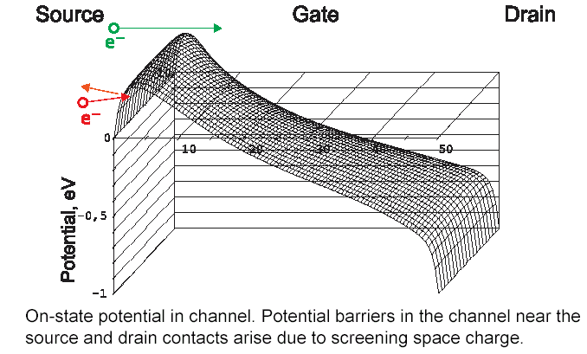
Figure 1.

The intermediate model and associated program BALSOI already developed at FTIAN are stepping to all quantum simulation of a nanoscale transistor. It looks as quite adequate for simulation of silicon-on-insulator MOSFETs with a channel length down to 50nm. The model is based on factorization of the electron motion inside the channel into quantum transversal and classical longitudinal motion.
In all-quantum simulation (program QUASOI) which is now in progress we intend to calculate transition coefficients T_{ij} and then evaluate current via Landauer formalism. The main goal is to clarify the impact of interference on charged impurities and self-consistent potential on I-V curve reproducibility for different randomly doped transistors in a circuit.

Acknowledgement.
The research was supported by NIX Computer Company (science@nix.ru), grant #F793/8-05, and Russian Basic Research Foundation, grants #06-07-89151-а and #06-01-00097-а.

- A. A. Sidorov, V. V. V’yurkov, and A. A. Orlikovsky. Russian Microelectronics, 2004, v. 33, N 4, pp. 195-205.
- V. V. V’yurkov, A. A. Orlikovsky, and A. A. Sidorov. Russian Microelectronics, 2003, v. 32, N 4, pp. 224-232.
- S. D. Ananiev, V. V. V'yurkov, and V. F. Lukichev. Proc. SPIE, 2006, v. 6260, to be published.

